Installing Oracle 12c in Windows - <https://edelivery.oracle.com/osdc/faces/SoftwareDelivery>

Installing Oracle Database 12c

To download and install Oracle Database, refer to the Oracle Technology Network (OTN) website at <http://www.oracle.com/technetwork/database/enterprise-edition/downloads/index.html>.

Simphony release 18.2 is not supported with pluggable databases.

To install Oracle Database 12c for a Simphony installation:

1. Place the Oracle Database installation media onto your database server.
2. Open the source installation file and run the setup executable.
3. To receive security updates from My Oracle Support, enter both your email address and My Oracle Support password and click **Next**.

If you deselect the **I wish to receive security updates via My Oracle Support** checkbox, a message prompt appears. Click **Yes**, and then click **Next**.

***Figure 2-27 Configure Security Updates***

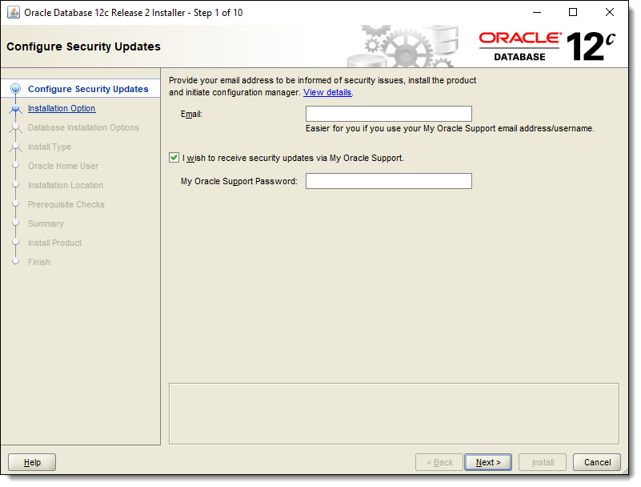

1. Select **Create and configure database**, and then click **Next**.

***Figure 2-28 Select Installation Option***

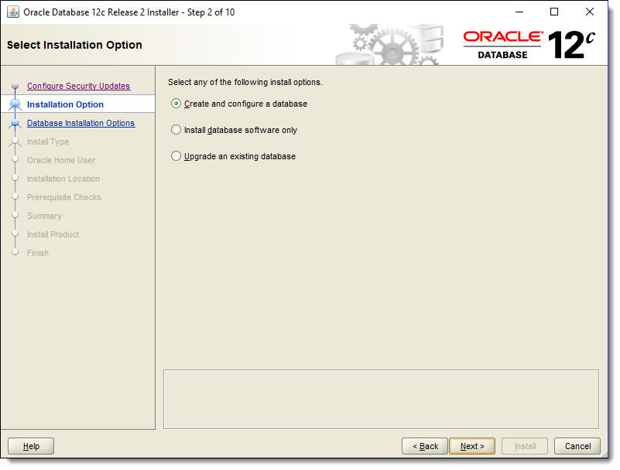

1. Select **Server class**, and then click **Next**.

***Figure 2-29 Select System Class***

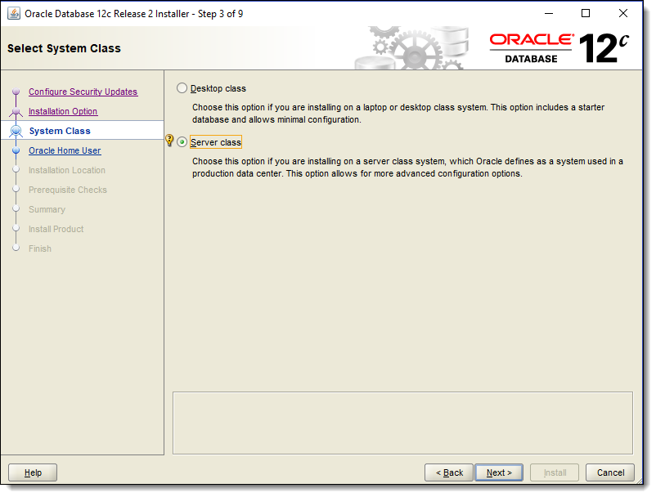

1. Select **Single instance database installation**, and then click **Next**.

***Figure 2-30 Select Database Installation Option***

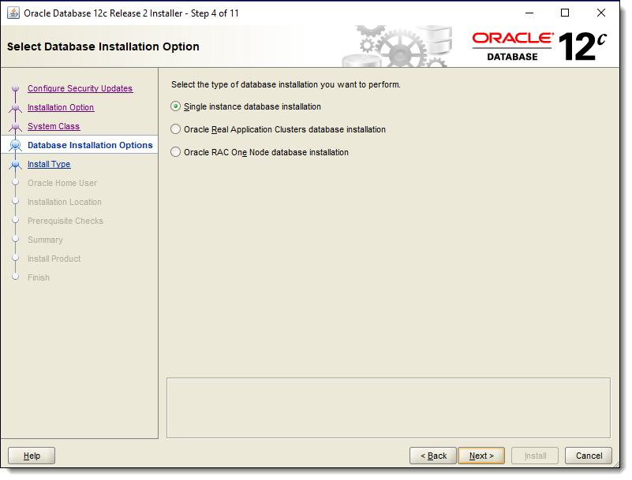

1. Select **Advanced install**, and then click **Next**.

***Figure 2-31 Select Install Type***

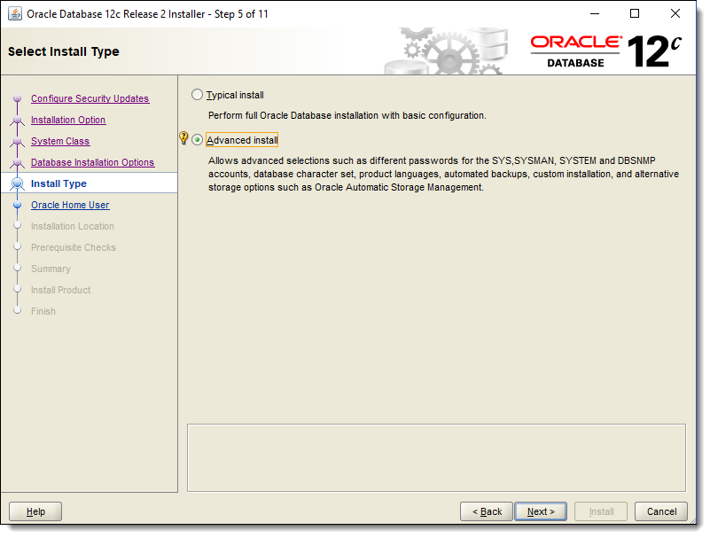

1. Select **Enterprise Edition (6.0GB)**, and then click **Next**.

***Figure 2-32 Select Database Edition***

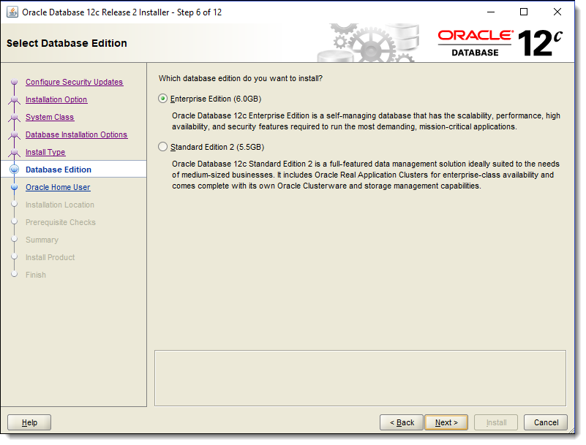

1. Select **Use Windows Built-in Account**, and then click **Next**. A message prompt appears. Click **Yes**, and then click **Next**.

***Figure 2-33 Specify Oracle Home User***

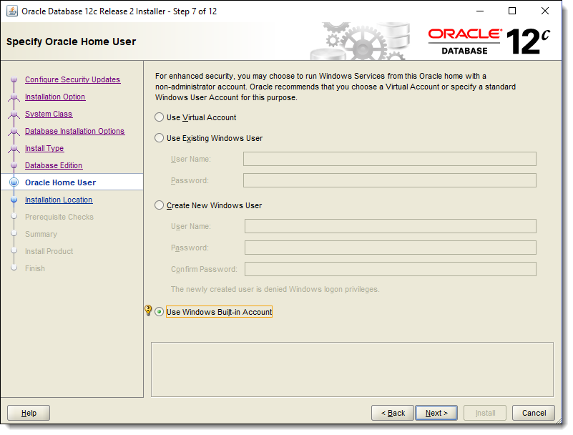

1. Select an appropriate installation location in the **Oracle base** field to place database configuration-related files (or example, C:\Oracle). Specify the location for storing Oracle database software files separate form database configuration files in the **Software location** field, and then click **Next**.

***Figure 2-34 Specify Installation Location***

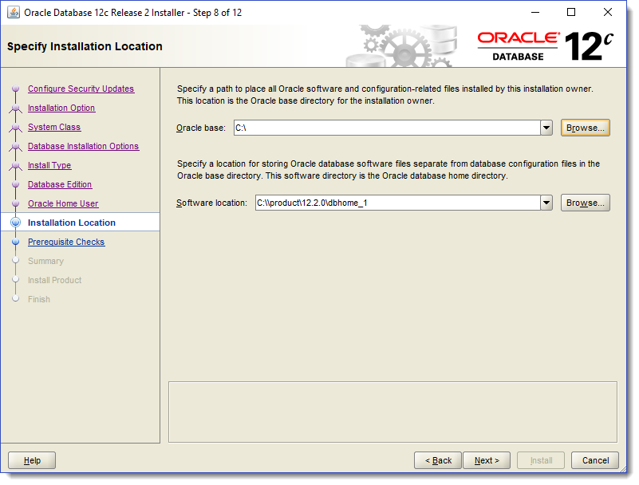

1. Select **General Purpose / Transaction Processing**, and then click **Next**.

***Figure 2-35 Select Configuration Type***

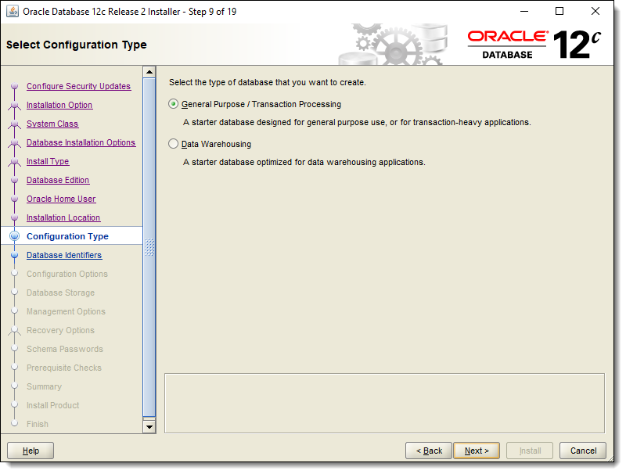

1. Enter **simphony** for the **Global database name** and **Oracle system identifier (SID)** fields. Deselect the checkbox adjacent to the **Create as Container database** option, and then click **Next**.

***Figure 2-36 Specify Database Identifiers***

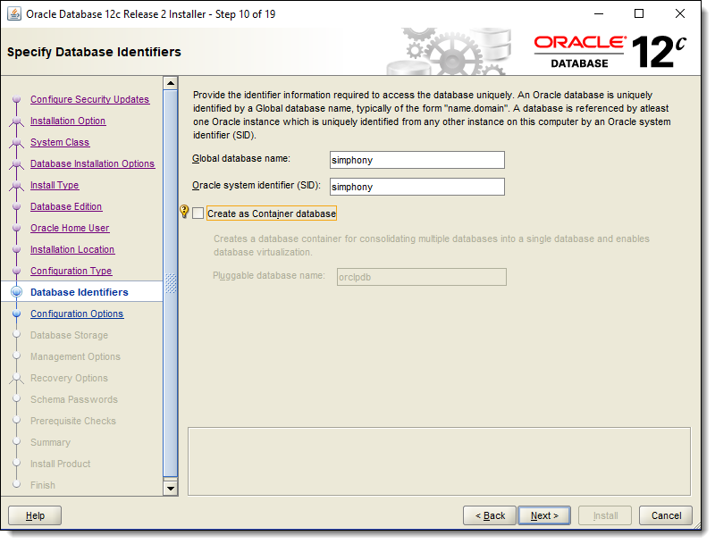

1. Select the checkbox adjacent to the **Automatic Memory Management** option.

This feature is not supported if there is more than 4GB of memory installed on your system. Deselect the option if the system exceeds 4GB of memory. A message prompt appears if the system exceeds 4GB of RAM. Consult with an Oracle DBA to if you need to adjust memory settings.

***Figure 2-37 Specify Configuration Options - Memory Tab***

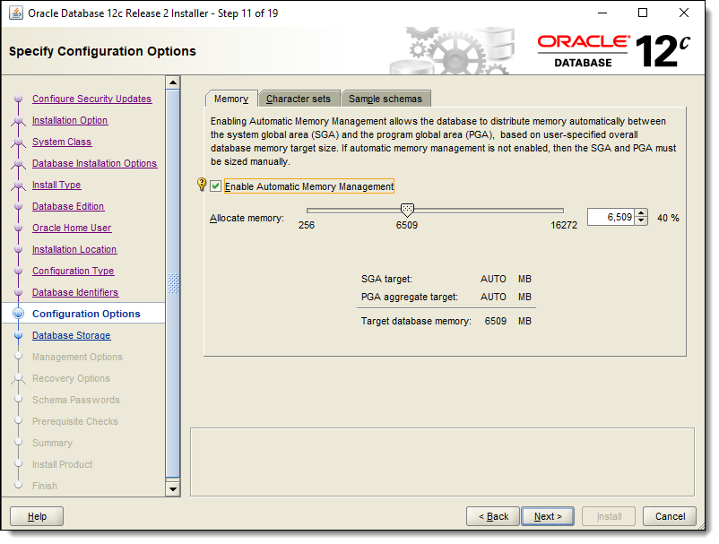

1. Select the **Character sets** tab, select **Use Unicode (AL32UTF8)**, and then click **Next**. This setting is required.

***Figure 2-38 Specify Configuration Options - Character sets Tab***

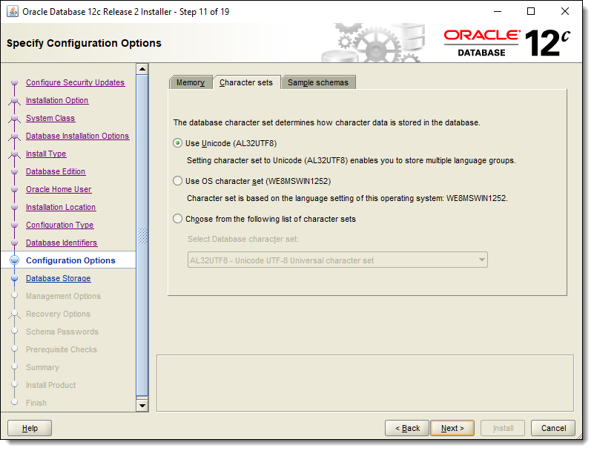

1. Select the **Sample schemas** tab, deselect the **Install sample schemas in the database** checkbox, and then click **Next**.

***Figure 2-39 Specify Configuration Options - Sample schemas Tab***

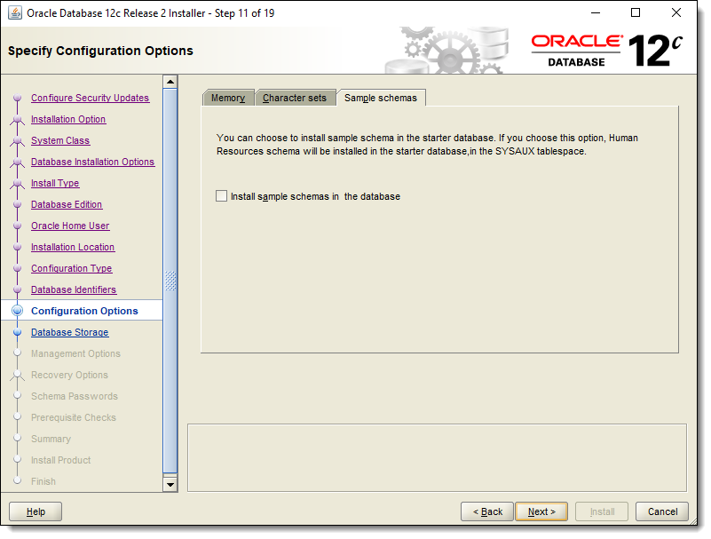

1. Select **File system**, and then click **Next**.

***Figure 2-40 Specify Database Storage Options***

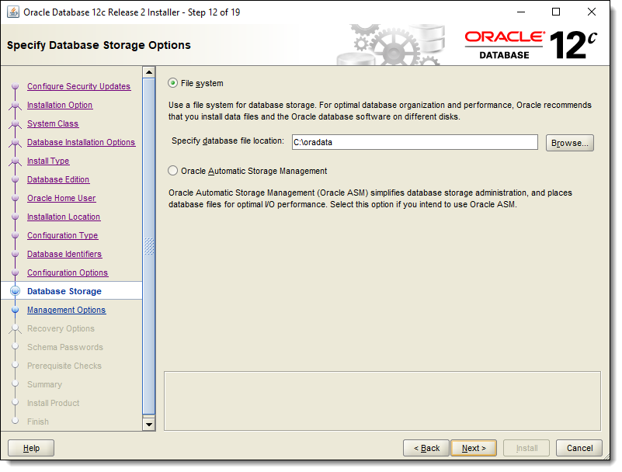

1. Deselect the checkbox adjacent to the **Register with Enterprise Manager (EM) Cloud Control** option, and then click **Next**.

***Figure 2-41 Specify Management Options***

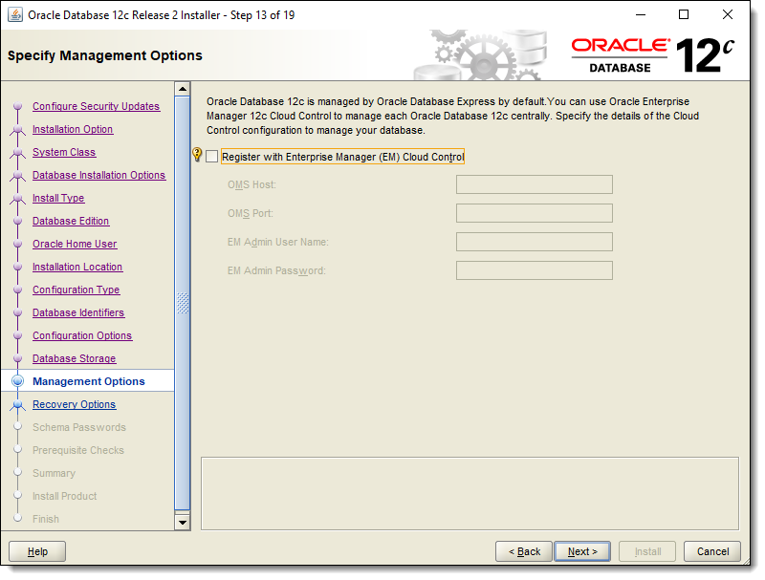

1. Deselect the checkbox adjacent to the **Enable Recovery** option, and then click **Next**.

***Figure 2-42 Specify Recovery Options***

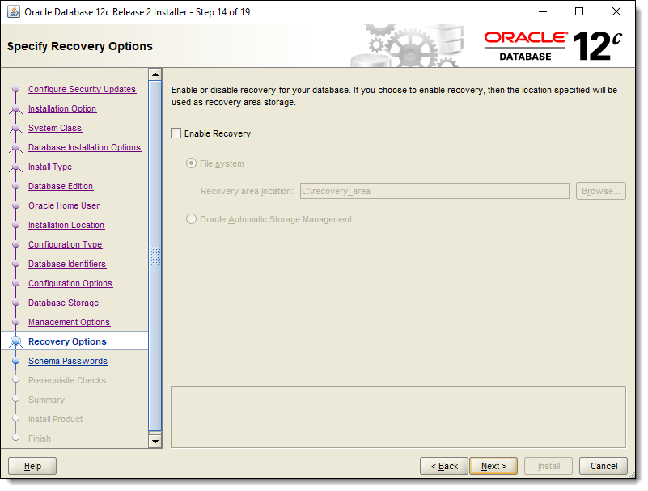

1. Select **Use the same password for all accounts**, enter and confirm your password, and then click **Next**.

***Figure 2-43 Specify Schema Passwords***

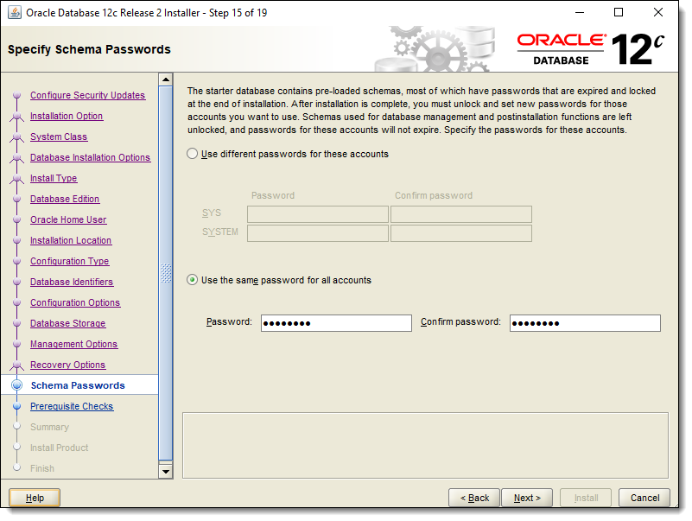

1. Before initiating the install, a prerequisite check is performed by the Oracle Database installation application. Click **Next**.

***Figure 2-44 Perform Prerequisite Checks***

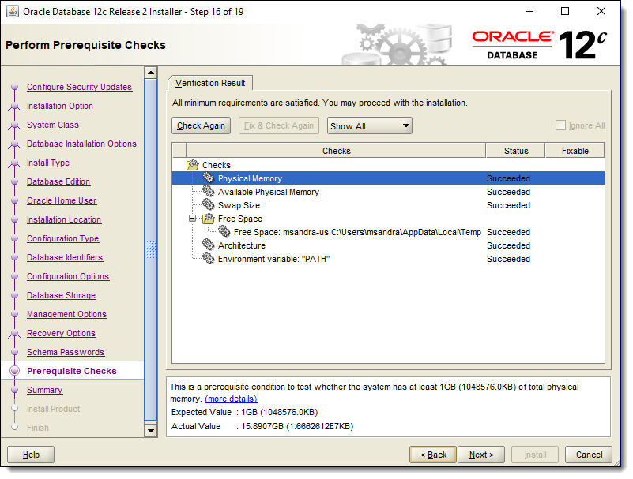

1. A summary window appears. Review it, and if correct, click **Install**.

***Figure 2-45 Summary***

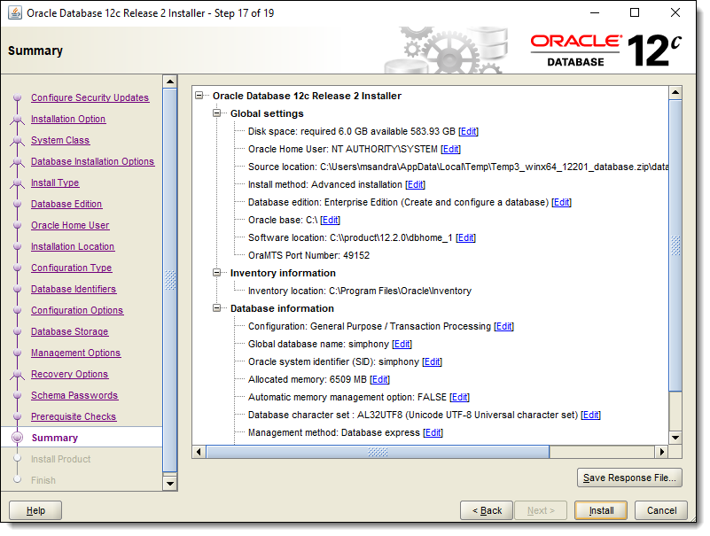

**Parent topic:** [Database Platform Installation](https://docs.oracle.com/cd/F10429_01/doc.182/e99060/c_preinstall_db_configuration.htm)